0563
WILLIAM SOMERVILLE(Capt. William)
of Ardrass, Celbridge. Co Kildare.

Son of Major William Somerville (0541) by his second wife Elizabeth Monroe (0543).

Birth: 7 Mar 1776
Bapt: 14 Mar 1776, St Thomas’ Church, Dublin
Marriage: 30 Aug 1800 at Roscrea, Co Tipperary, to Elizabeth Bellingham (Eliza),
second daughter of Col. Henry Bellingham of Castle Bellingham, Co
Louth, by his wife Eliza Tenison.
Death: 19 Dec 1844 at Guild St., Dublin
Buried: 21 Dec 1844 St Audoen’s Dublin.

Father of:
William Henry Somerville, b. 13th January 1802
Archibald James Somerville, b. 13th May 1803
John Churchill Somerville, b. 19th December 1804
Corry Somerville, b.19th March 1806
Bellingham Arthur Somerville, b. 15th April 1810
Tenison Sonerville, b. 10th August 1812
Tenison Alan Somerville,b. 16th December 1815
Samuel Riall Somerville, b. 26th November 1820
Elizabeth Bellingham Somerville, b. 1st February 1808
Eliza Somerville, b. 13th September 1813

Source: Somerville Index.

Notes:

SR3011: Capt in the South Cork Light Infantry and in the Louth Militia.
10 Jan 1842 admitted to the Freedom of the City of Dublin.

SR 3003M Baptismal Certificates from St Thomas’Church and certified copy from PRO,Dublin

SR3537 Marriage Settlement dated 8th December 1800 made between William
Somerville, Elizabeth Somerville, otherwise Bellingham, his wife, Elizabeth
Bellingham, widow, of Castle Bellingham and Alan Bellingham.
Memorial of Deed, registered in Registry of Deeds 12th December 1800-Book
532, page 300, No 349370. (see SR1710 which suggests the page may be 373)

While Capt William has always been described as ‘of Ardrass’, there is
noevidence that he lived there. He clearly received rents out of Ardrass, from the
evidence of part of a Rent book, and it seems that he put all, or a portion, of
these rents into his Marriage Settlement. After his death, it seems the
beneficiaries of the Settlement had problems with the Bellingham trustee.
WBRBS has been informed by a friend at Celbridge (the genealogist Harry

McDowell) that the main house at
Ardrass was pulled down in the 1950s. By the time of his death in 1844, 5 years
after Eliza’s, Capt William was living in Guild Street in lodgings with his son
Bellingham Arthur (0589) who died shortly before him, in reduced
circumstances.

Capt William kept a Diary from 1st May 1811 to 24th November 1844. This Diary
was not known to exist, and not ‘discovered’, until after the death of Cecilia Eliza
Somerville (0592), widow of Tenison Alan Somerville (0591), in 1898 when
the contents of 3,
Leinster Road were being cleared. Unfortunately, the children of BAS ((0631)
were
assisting and, Tetty (0680) believes, tore up much of the Diary. Consequently, of
the years from 1822 to
1844, 1822 is missing, 1823 and 4 are complete, 1825 to May 1833 are missing,
June to September 1833 survive, October1833 to February 1835 are missing
March 1835 survives, April 1835 to January 1838 are missing, February 1838
survives, March 1838 to December 1838 are missing and 1839 to 1844 are
complete.

Capt. William lead a peripatetic existence, at any rate during the twenty years
after his marriage. None of his ten children were born in the same place. We have
no record of his service in the South Cork Light Infantry, but it seems to have
involved being stationed both in Ireland and England. But by 1812, it looks as if he
had joined the Louth Militia. No record of his military career is known to exist.

We have a full picture of his life as a small, probably tenant, farmer at Cumry
Lodge, near Ballibay both from his Diary and subsequent correspondence
between his children. He lived there from about 1819 until 1830 when he moved
to Farm,Galoon, co Fermanagh and thereafter to Dublin in 1835/6

SR2003: Will drafted 14 Dec 1844. Proved 29 May 1845.(Prerogative Wills 1845.
Vol.2.NtoZ Folio 180)
Following is an extract:

I, William Somerville formerly of 34, Bay View Avenue in the Co of the City of
Dublin ……..
On the death of my late dearly beloved wife Eliza Somerville otherwise
Bellingham second daughter of the late Henry Bellingham of Castle Bellingham in
the County of Louth late Lieut. Col in the Louth Regiment of Militia deceased
I became entitled to dispose of £1,000 amongst my children by the said Eliza
Somerville …. Which sum was raised off the Castle Bellingham Estate in 1824 and
lent to John Woolsey of Milestown Cstlebellingham at the rate of 5% amount to
be paid half yearly on 1st August and 1st February …
To my eldest son Wm Henry £200…
To my second son Archibald James£400 ….
To my third son Corry £100 …
Corry S when I last heard of him now nearly 5 years ago was living at Rochester,
Monroe County, State of New York Should he be dead his share to be divided
amongst his brothers Wm Henry, Archibald James, Tenison Alan and his only
sister
Eliza Nelson equally …..
To my fifth son Tenison Alan Somerville £200 ….
To my only daughter Eliza Nelson wife of Thos Nelson £100 and in case of her
death to go to her children …
To Mary Jane Hagerty only daughter of James Coghill Hagerty ….
My son Archibald James and Edward Henry Hagerty of Upper Dorset St Dublin to
be my Executors Dated 14th December 1844

Witnesses J Hagarty Jr Dal Lawton

Probate of Will of William Somerville late of Guild St in the City of Dublin granted
to Archibald James Somerville of the Island of Trinidad son of deceased one of the
Executors of said will.Granted 29th May 1845.

SR 1637 Parish Register St Audoens
‘ 21st Dec 1844 William Somerville aged 68 years buried’

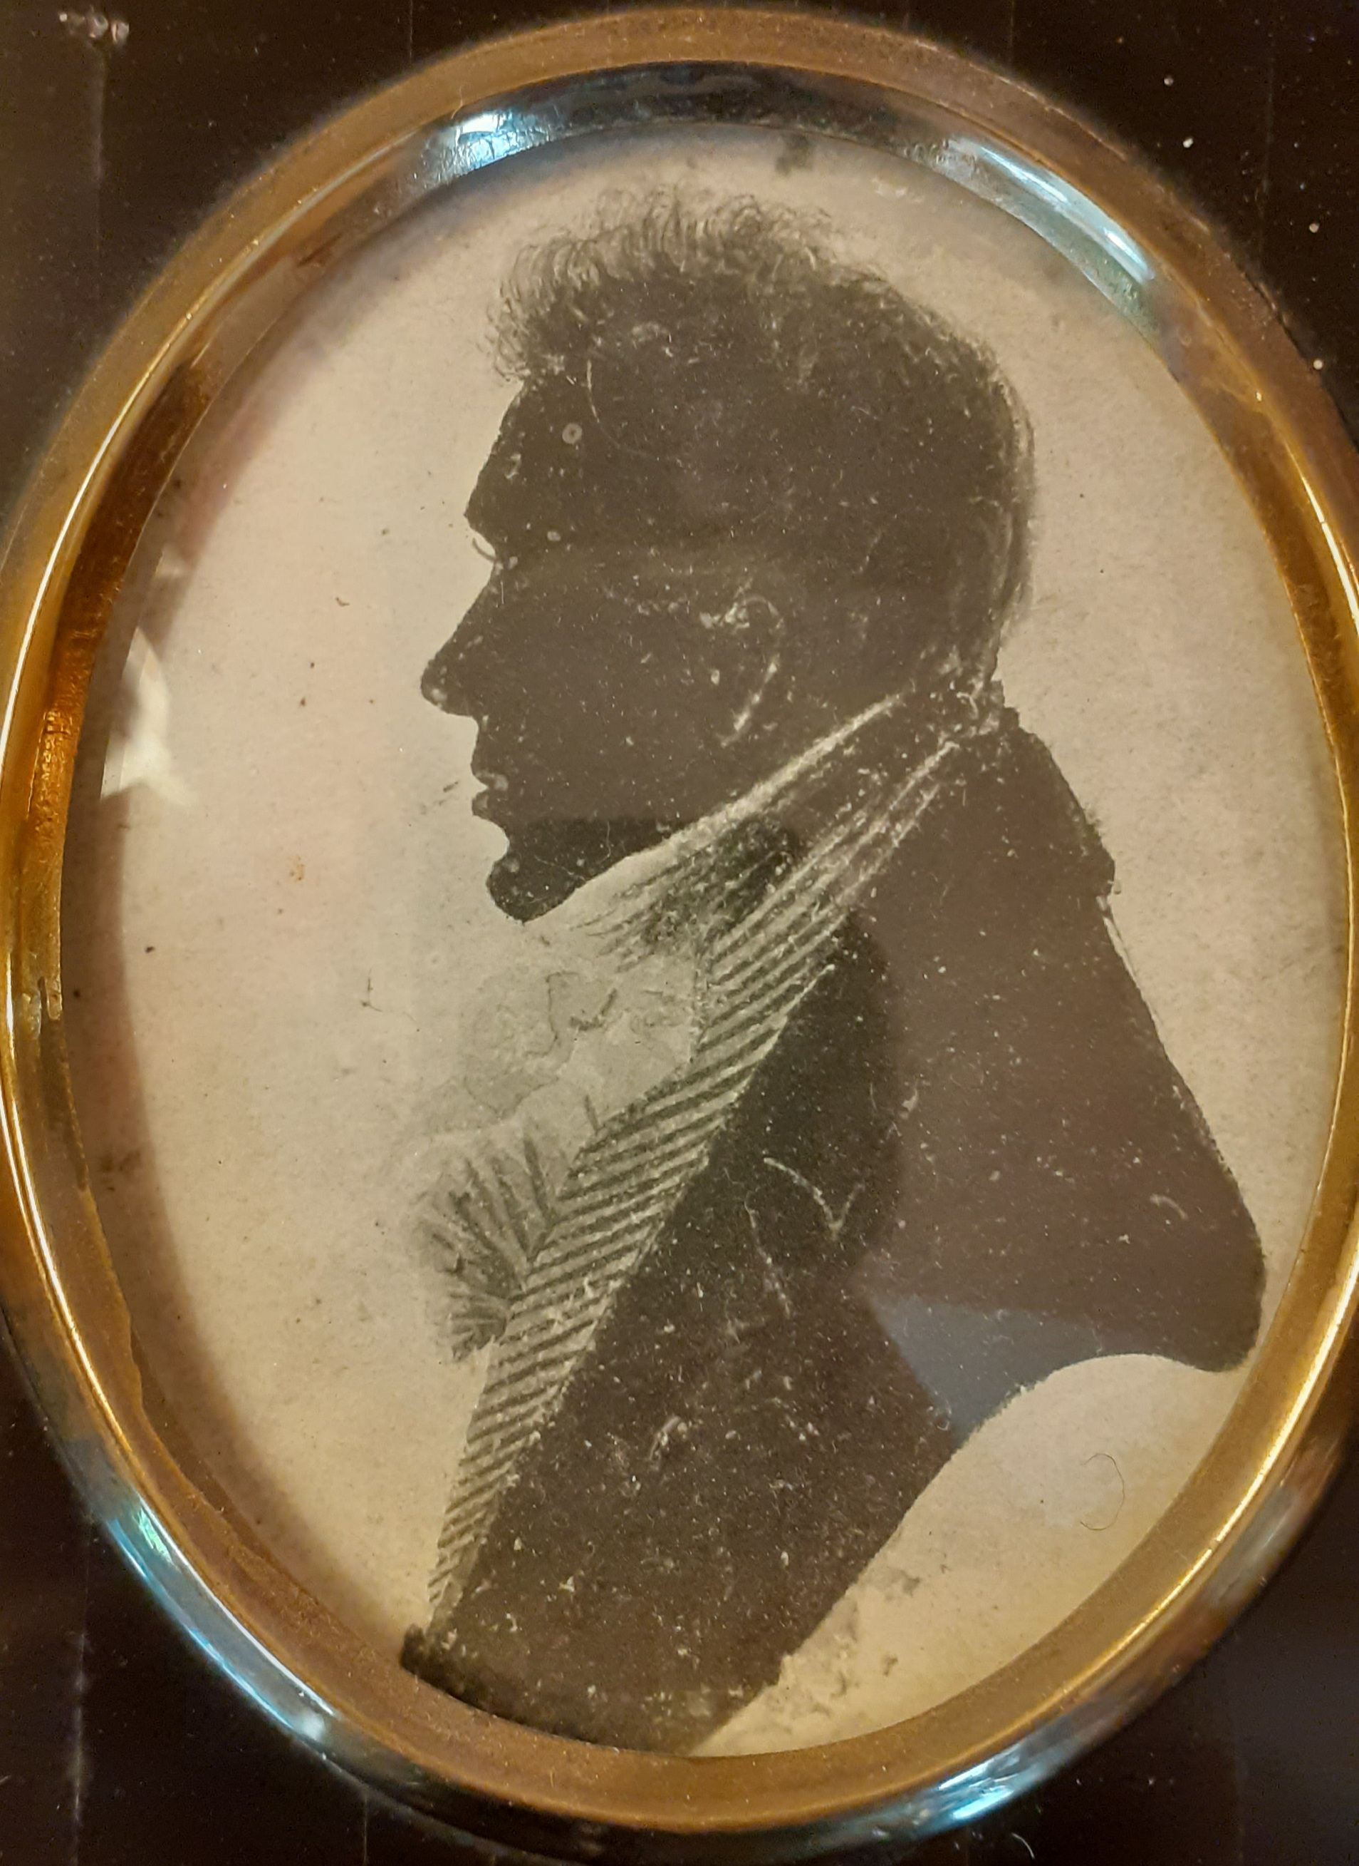
Silhouette, believed to be Capt William Somerville.

Source: Somerville Records, researches by Regi, Tetty and WBRBS. More information and
anecdotes are to be found in the Diary and family correspondence.

